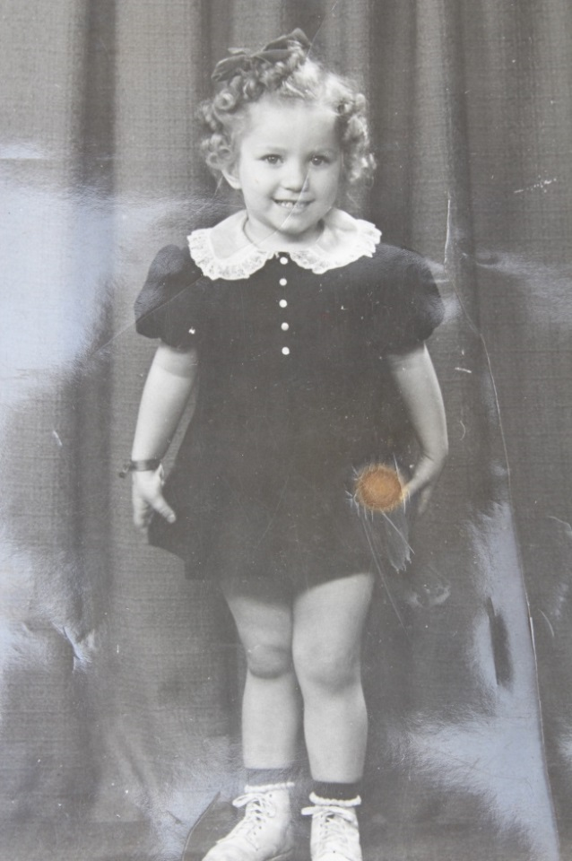

**Carolyn Wilhemina Huffer List – 1940**

|  |  |  |
| --- | --- | --- |
| |  |  | | --- | --- | | **C:\Users\Richard\Documents\Family Tree Maker\Book Material - Wolfe\Pics fm David List 8April2014\156-c.jpg**  **1947** | **C:\Users\Richard\Documents\Family Tree Maker\Book Material - Wolfe\Pics fm David List 8April2014\005-c.jpg**  **1956** | |

**Carolyn Wilhemina Huffer List**